**Biometric Voting System User Manual**

**INSTRUCTIONS**

Open the Xampp control panel and start the Apache and MySQL modules before launching the application to make sure the services are up and running.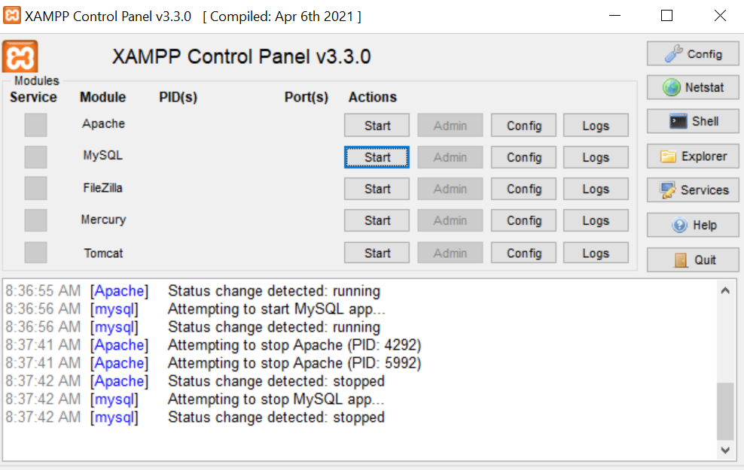 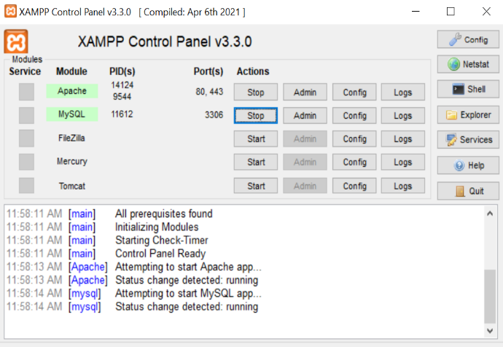

Additionally, you should confirm that the device and the host computer are linked to the same network, such as a mobile hotspot.

A log-in form appears once the application has launched. In order to access the system, enter the following information. Password: "2023" Username: "zec". You should make sure the password and username are correct otherwise an error message would be produced

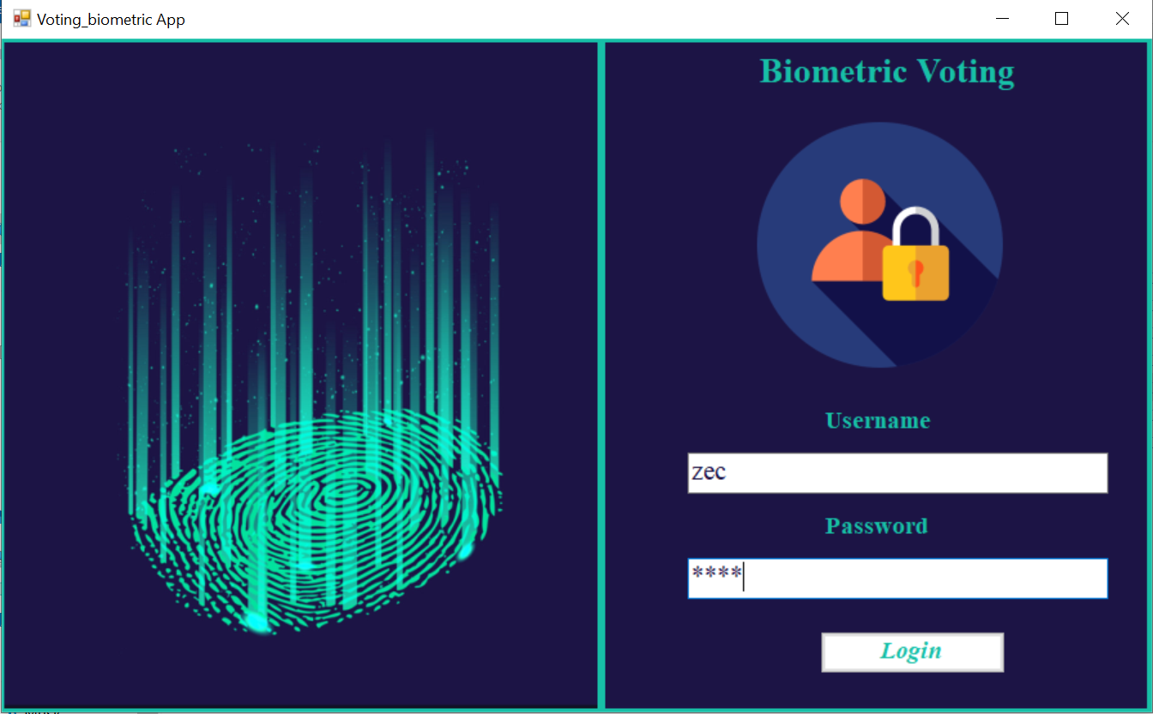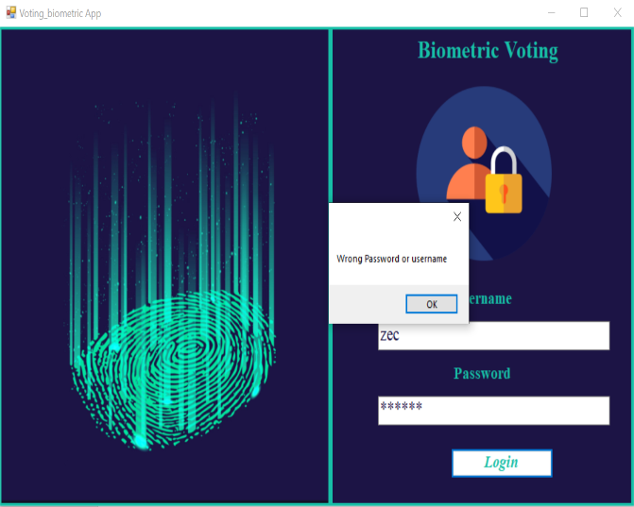

**Registering a Voter**

Fill out every field when registering a voter before saving the data to avoid receiving an error notice. Before scanning the fingerprints, make sure the fingerprint scanner is powered on.

When the LCD on the device indicates "Enrolling voter," press the scan button on the interface and place your finger on the scanner. When the scanner's light is not flashing, hold the button; when it is, release it. Repeat the procedure up until the CD shows the fingerprint's ID.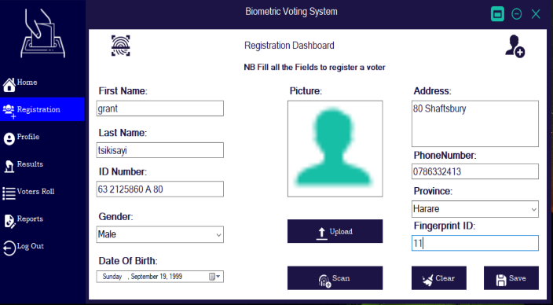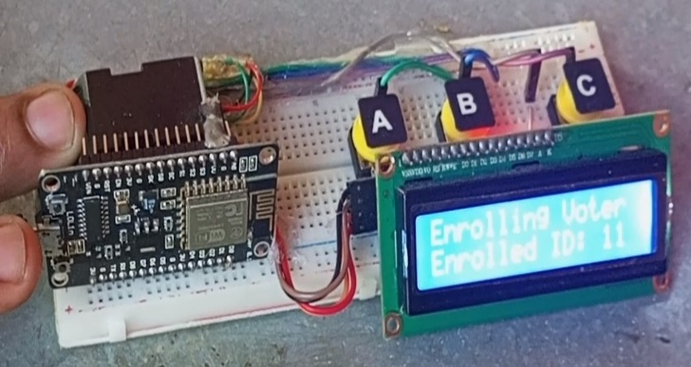**Profile**

A registered voter's information can be changed or removed on this page. Enter their ID and hit search to see their details. Press update to save changed data or delete to remove the entire record.

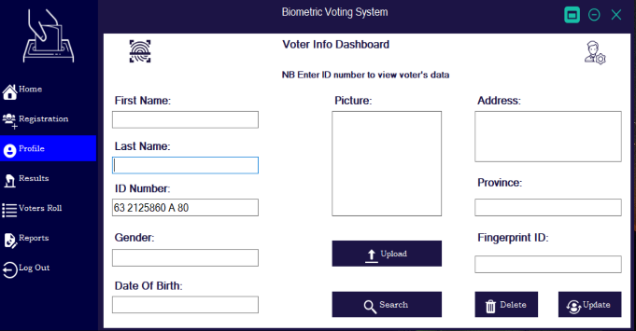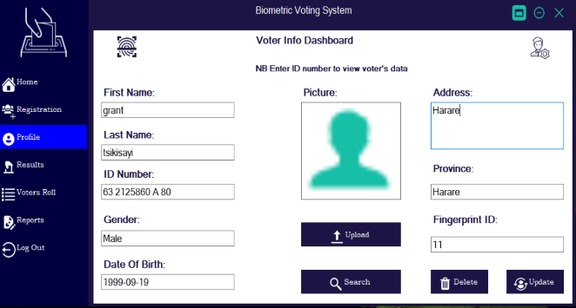

**Results**

The election results are shown here in real time. Additionally, each party's proportion of votes is displayed.

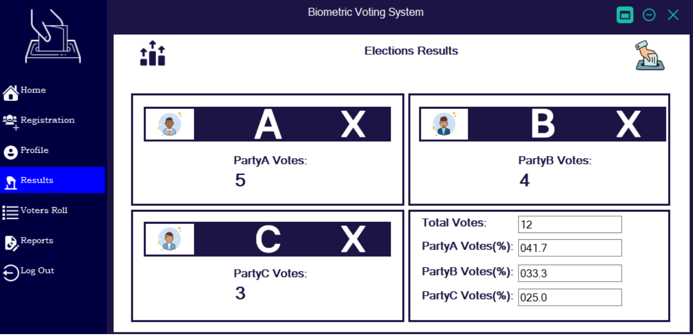

**Voter’s Role**

On this page, registered voters are listed. The data can also be filtered to just show voters who are male or female.

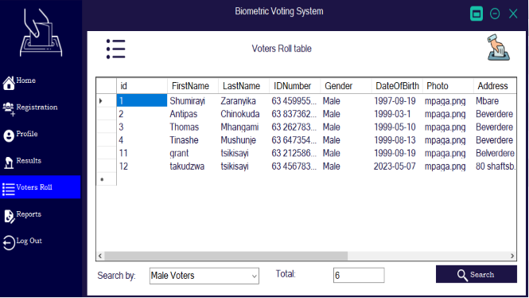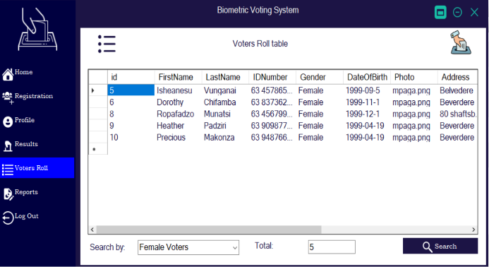

**Report**

You can export the results to an excel file by pressing the export button on this area, or you can print the results to get the reports.

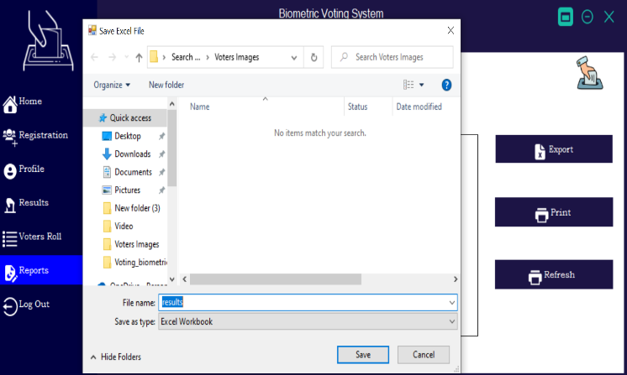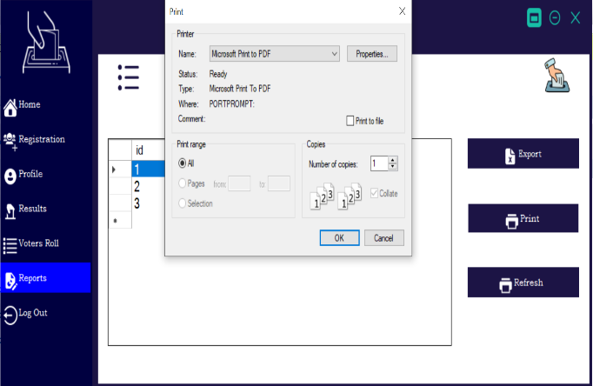

**Voting**

Put your registered fingerprint on the scanner. Hold off until "Select Party" appears on the LCD.

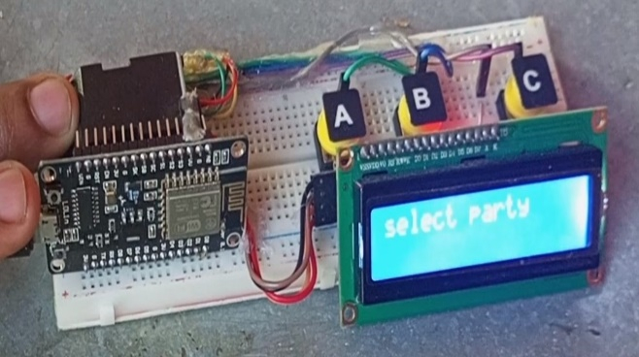

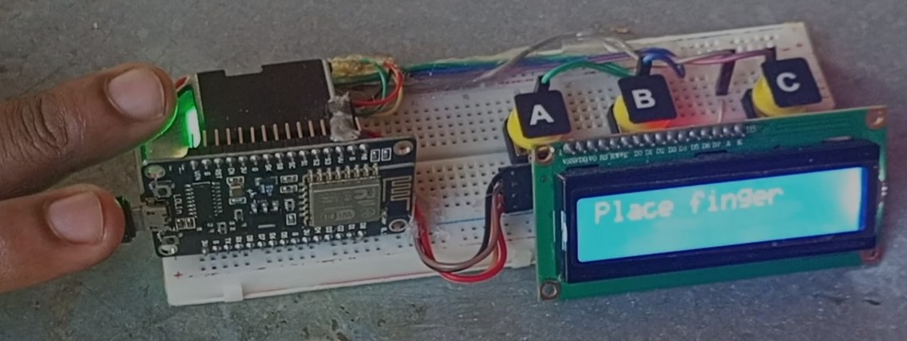

The CD will say "Alert voting successful" once you press the designated button for the party of your choosing and hold it.

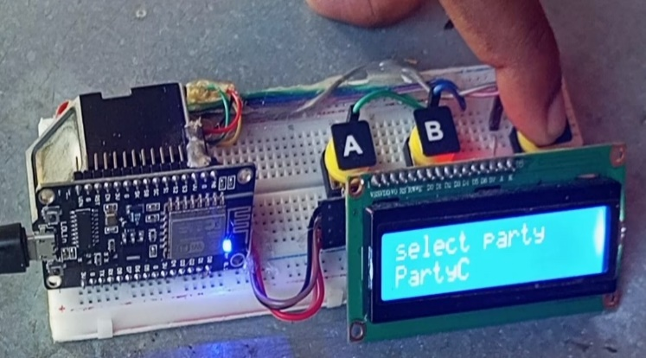 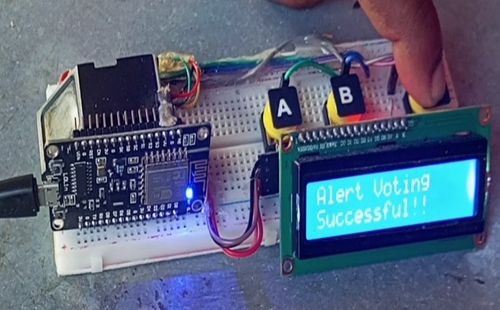

An error message is displayed on the LCD if the voter is not registered, and it also appears if the voter has already cast a vote.

